**Global Sales Data Analytics**

|  |  |
| --- | --- |
| **Date** | **02-11-2022** |
| **Team ID** | **PNT2022TMID45267** |
| **Project Name** | **Global Sales Data Analytics** |

Data Flow Diagrams

**A data flow diagram (DFD) maps out the flow of information for any process or system. It uses defined symbols like rectangles, circles and arrows, plus short text labels, to show data inputs, outputs, storage points and the routes between each destination. Data flowcharts can range from simple, even hand-drawn process overviews, to in-depth, multi-level DFDs that dig progressively deeper into how the data is handled. They can be used to analyze an existing system or model a new one. Like all the best diagrams and charts, a DFD can often visually “say” things that would be hard to explain in words, and they work for both technical and nontechnical audiences, from developer to CEO. That’s why DFDs remain so popular after all these years. While they work well for data flow software and systems, they are less applicable nowadays to visualizing interactive, real-time or database-oriented software or systems.**

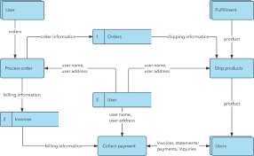

Data Flow Diagram symbols are standardized notations, like rectangles, circles, arrows, and short-text labels, that describe a system or process’ data flow direction, data inputs, data outputs, data storage points, and its various sub-processes.

There are four common methods of notation used in DFDs: Yourdon & De Marco, Gene & Sarson, SSADM and Unified. All use the same labels and similar shapes to represent the four main elements of a DFD — external entity, process, data store, and data flow.

